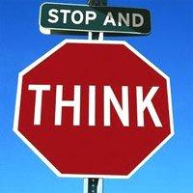Washington Intermediate School

Name

Date Teacher

Think Sheet was completed in:

**__** Safe Seat __ Buddy Room __ Office

**Please check the Best Behavior expectation that was not being followed.**

**__** Be Trustworthy __ Be Respectful __ Be Responsible __ Show Pride in self/work

**What was I doing?**

**What should I have been doing?**

**Do you need help following the expectations of our school? YES NO**

**Student Signature**

Parent Signature

*WORK TO BE COMPLETED (TEACHER SHOULD FILL OUT PRIOR TO STUDENT LEAVING ROOM):*

*(Teacher) Was work completed on time YES NO*

 Washington Intermediate School

Behavior while visiting Buddy Work to be completed:

Room:

__ Acceptable

__ Unacceptable

Name

Date Teacher

Arrival Return Host Initials

Parent Signature

(as needed)

Washington Intermediate School

C:\Users\ehmkes\AppData\Local\Microsoft\Windows\Temporary Internet Files\Content.IE5\JCYW0XJS\MCj04231690000[1].wmf

C:\Users\ehmkes\AppData\Local\Microsoft\Windows\Temporary Internet Files\Content.IE5\X4O96WSX\MCj04231650000[1].wmfDraw a picture showing what you did. Draw a picture showing what you should have done.

**In the future you will….**

Behavior while visiting Buddy Note from teacher:

Room:

__ Acceptable

__ Unacceptable

Parent Signature

(as needed)